HMI Design Spezifikation

# Übersicht

Ein Bild, das Text, Screenshot, Zahl, Uhr enthält.

L1

L2

L3

L4

L5

L6

L7

B1

B2

B3

B4

B5

B6

B7

B8

B9

L1 - L7 LEDs

B1 – B5 Knöpfe die mit 3 s debounced werden

B6 – B9 Knöpfe die mit 1 s debounced werden

# Statemachine

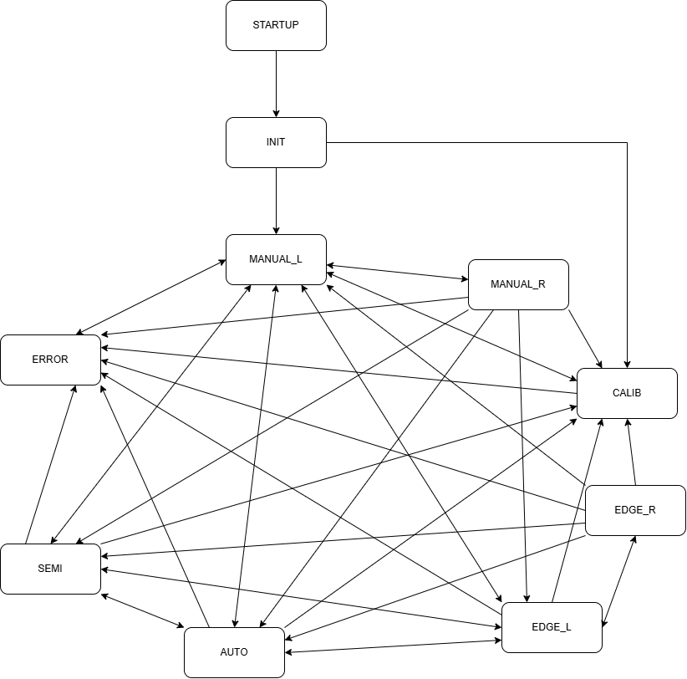

Alle Verbindungen zum ERROR-State sind im nachfolgenden Kapitel nicht mehr aufgeführt und können durch jeden Fehler zu jedem Zustand hervorgerufen werden.

Der Übergang von STARTUP nach INIT erfolgt nach 10 s.

# UI Konzept

|  |  |  |  |
| --- | --- | --- | --- |
| **Platzhalter** | **Bezeichnung** | **Range** | **Redis Variable** |
| 123 | kalibrierte Position virtueller Anschlag | 0-1023 | hmi_vend_ist |
| 111 | Sollposition virtueller Anschlag | 0-1023 | hmi_vend_soll |
| 11% | Istposition Motor links | 0-100% | hmi_pos_l |
| 22% | Istposition Motor rechts | 0-100% | hmi_pos_r |
| 33% | Sollposition Motor links | 0-100% | hmi_soll_l |
| 44% | Sollposition Motor rechts | 0-100% | hmi_soll_r |
| Feldname | Name des geladenen Feldes | ?? | hmi_feldname |
| 25 km/h | aktuelle Geschwindigkeit | ?? | hmi_speed |
| GPS: ok | Status des GPS | ?? | hmi_gps |
| - | State | - | hmi_state |
| - | Fehler | 0x01-0x99 | hmi_fehler |

Alle Variablen sind vom Datentyp String.

## STARTUP

|  |  |  |  |  |  |  |  |  |  |  |  |  |  |  |  |  |  |  |  |  |  |
| --- | --- | --- | --- | --- | --- | --- | --- | --- | --- | --- | --- | --- | --- | --- | --- | --- | --- | --- | --- | --- | --- |
|  | |  |  | | --- | --- | | **Knopf** | **Funktion** | | B1 | - | | B2 | - | | B3 | - | | B4 | - | | B5 | - | | B6 | - | | B7 | - | | B8 | - | | B9 | - | |

## INIT

|  |  |  |  |  |  |  |  |  |  |  |  |  |  |  |  |  |  |  |  |  |  |
| --- | --- | --- | --- | --- | --- | --- | --- | --- | --- | --- | --- | --- | --- | --- | --- | --- | --- | --- | --- | --- | --- |
| Ein Bild, das Text, Screenshot, Schrift, Multimedia-Software enthält.  KI-generierte Inhalte können fehlerhaft sein. | |  |  | | --- | --- | | **Knopf** | **Funktion** | | B1 | - | | B2 | - | | B3 | - | | B4 | - | | B5 | - | | B6 | - | | B7 | - | | B8 | * MANUAL_L | | B9 | * CALIB | |

## CALIB

|  |  |  |  |  |  |  |  |  |  |  |  |  |  |  |  |  |  |  |  |  |  |
| --- | --- | --- | --- | --- | --- | --- | --- | --- | --- | --- | --- | --- | --- | --- | --- | --- | --- | --- | --- | --- | --- |
|  | |  |  | | --- | --- | | **Knopf** | **Funktion** | | B1 | * AUTO | | B2 | * SEMI | | B3 | * MANUAL_L | | B4 | * EDGE_L | | B5 | vend_prov speichern   * MANUAL_L | | B6 | inkrementieren vend_prov | | B7 | dekrementieren vend_prov | | B8 | - | | B9 | Motor links auf vend_prov fahren | |

## MANUAL_L

|  |  |  |  |  |  |  |  |  |  |  |  |  |  |  |  |  |  |  |  |  |  |
| --- | --- | --- | --- | --- | --- | --- | --- | --- | --- | --- | --- | --- | --- | --- | --- | --- | --- | --- | --- | --- | --- |
|  | |  |  | | --- | --- | | **Knopf** | **Funktion** | | B1 | * AUTO | | B2 | * SEMI | | B3 | - | | B4 | * EDGE_L | | B5 | * CALIB | | B6 | Motor links öffnen | | B7 | Motor links schliessen | | B8 | - | | B9 | * MANUAL_R | |

## MANUAL_R

|  |  |  |  |  |  |  |  |  |  |  |  |  |  |  |  |  |  |  |  |  |  |
| --- | --- | --- | --- | --- | --- | --- | --- | --- | --- | --- | --- | --- | --- | --- | --- | --- | --- | --- | --- | --- | --- |
|  | |  |  | | --- | --- | | **Knopf** | **Funktion** | | B1 | * AUTO | | B2 | * SEMI | | B3 | - | | B4 | * EDGE_L | | B5 | * CALIB | | B6 | Motor rechts öffnen | | B7 | Motor rechts schliessen | | B8 | - | | B9 | * MANUAL_L | |

## SEMI

|  |  |  |  |  |  |  |  |  |  |  |  |  |  |  |  |  |  |  |  |  |  |
| --- | --- | --- | --- | --- | --- | --- | --- | --- | --- | --- | --- | --- | --- | --- | --- | --- | --- | --- | --- | --- | --- |
|  | |  |  | | --- | --- | | **Knopf** | **Funktion** | | B1 | * AUTO | | B2 | - | | B3 | * MANUAL_L | | B4 | * EDGE_L | | B5 | * CALIB | | B6 | Beide Motoren auf 100% fahren | | B7 | Beide Motoren auf 0% fahren | | B8 | - | | B9 | - | |

## AUTO

|  |  |  |  |  |  |  |  |  |  |  |  |  |  |  |  |  |  |  |  |  |  |
| --- | --- | --- | --- | --- | --- | --- | --- | --- | --- | --- | --- | --- | --- | --- | --- | --- | --- | --- | --- | --- | --- |
| Ein Bild, das Text, Screenshot, Schrift, Multimedia-Software enthält.  KI-generierte Inhalte können fehlerhaft sein. | |  |  | | --- | --- | | **Knopf** | **Funktion** | | B1 | - | | B2 | * SEMI | | B3 | * MANUAL_L | | B4 | * EDGE_L | | B5 | * CALIB | | B6 | - | | B7 | - | | B8 | - | | B9 | - | |

## EDGE_L

|  |  |  |  |  |  |  |  |  |  |  |  |  |  |  |  |  |  |  |  |  |  |
| --- | --- | --- | --- | --- | --- | --- | --- | --- | --- | --- | --- | --- | --- | --- | --- | --- | --- | --- | --- | --- | --- |
| Ein Bild, das Text, Screenshot, Schrift, Multimedia-Software enthält.  KI-generierte Inhalte können fehlerhaft sein. | |  |  | | --- | --- | | **Knopf** | **Funktion** | | B1 | * AUTO | | B2 | * SEMI | | B3 | * MANUAL_L | | B4 | - | | B5 | * CALIB | | B6 | Motor links auf 100% fahren | | B7 | Motor links auf 0% fahren | | B8 | - | | B9 | * EDGE_R | |

## EDGE_R

|  |  |  |  |  |  |  |  |  |  |  |  |  |  |  |  |  |  |  |  |  |  |
| --- | --- | --- | --- | --- | --- | --- | --- | --- | --- | --- | --- | --- | --- | --- | --- | --- | --- | --- | --- | --- | --- |
| Ein Bild, das Text, Screenshot, Schrift, Multimedia-Software enthält.  KI-generierte Inhalte können fehlerhaft sein. | |  |  | | --- | --- | | **Knopf** | **Funktion** | | B1 | * AUTO | | B2 | * SEMI | | B3 | * MANUAL_L | | B4 | - | | B5 | * CALIB | | B6 | Motor rechts auf 100% fahren | | B7 | Motor rechts auf 0% fahren | | B8 | - | | B9 | * EDGE_L | |

## ERROR

|  |  |  |  |  |  |  |  |  |  |  |  |  |  |  |  |  |  |  |  |  |  |
| --- | --- | --- | --- | --- | --- | --- | --- | --- | --- | --- | --- | --- | --- | --- | --- | --- | --- | --- | --- | --- | --- |
| Ein Bild, das Text, Screenshot, Schrift, Multimedia-Software enthält.  KI-generierte Inhalte können fehlerhaft sein. | |  |  | | --- | --- | | **Knopf** | **Funktion** | | B1 | - | | B2 | - | | B3 | - | | B4 | - | | B5 | - | | B6 | - | | B7 | - | | B8 | - | | B9 | Fehler löschen   * MANUAL_L | |

|  |  |
| --- | --- |
| **Fehlercode** | **Text** |
| 0x01 | CAN-Bus Verbindungsunterbruch zum ControllerNano |
| 0x02 | CAN-Bus Verbindungsunterbruch zum Raspberry |
| 0x03 | Motor links einfahren blockiert |
| 0x04 | Motor links ausfahren blockiert |
| 0x05 | Motor rechts einfahren blockiert |
| 0x06 | Motor rechts ausfahren blockiert |
| 0x07 | ?? |

# Output-Definition

|  |  |  |  |  |  |  |  |
| --- | --- | --- | --- | --- | --- | --- | --- |
|  | L1 | L2 | L3 | L4 | L5 | L6 | L7 |
| **STARTUP** |  |  |  |  |  |  |  |
| **INIT** |  |  |  |  |  |  |  |
| **CALIB** |  |  |  |  |  |  |  |
| **MANUAL_L** |  |  |  |  |  |  |  |
| **MANUAL_R** |  |  |  |  |  |  |  |
| **SEMI** |  |  |  |  |  |  |  |
| **AUTO** |  |  |  |  |  |  |  |
| **EDGE_L** |  |  |  |  |  |  |  |
| **EDGE_R** |  |  |  |  |  |  |  |
| **ERROR** |  |  |  |  |  |  |  |

grün: ON

rot: OFF

blau: BLINK